**Homoscedasticity** and **heteroscedasticity** are key concepts in regression analysis and statistics that describe the distribution of residuals (errors) in a model. Understanding these terms is critical for evaluating the performance and reliability of regression models in bivariate analysis (involving two variables).

**Homoscedasticity**

**Definition**: Homoscedasticity occurs when the variance of residuals or errors remains constant across all levels of the independent variable. In other words, as the value of the predictor variable changes, the spread of the residuals should not systematically increase or decrease.

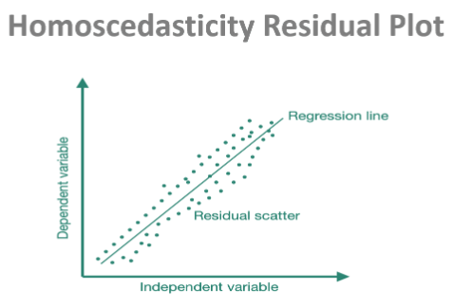

**Thumb Rule**:

* A common way to check for homoscedasticity is through a residual plot. If the residuals are randomly scattered around the horizontal axis with no visible pattern, the data is considered homoscedastic.

**Purpose**:

* The assumption of homoscedasticity is essential for ensuring that the estimates of regression coefficients are unbiased and efficient. It ensures that the standard errors of the coefficients are reliable, leading to valid hypothesis tests and confidence intervals.

**Importance**:

* Homoscedasticity ensures that the model’s predictions are equally reliable for all values of the independent variable. When this assumption holds, ordinary least squares (OLS) regression produces the most accurate estimates.

**Heteroscedasticity**

**Definition**: Heteroscedasticity occurs when the variance of residuals or errors varies at different levels of the independent variable. This means that as the value of the predictor changes, the spread of the residuals either increases or decreases systematically.

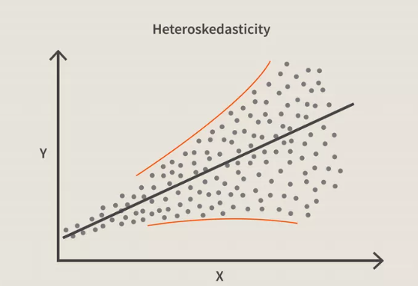

**Thumb Rule**:

* In a residual plot, heteroscedasticity is observed when the spread of residuals forms a distinct pattern, such as a fan shape or funnel, indicating that the error variance is not constant.

**Purpose**:

* Heteroscedasticity does not bias the regression coefficients, but it affects the efficiency of the estimates. The standard errors of the regression coefficients are underestimated or overestimated, leading to incorrect confidence intervals and hypothesis tests.

**Importance**:

* Heteroscedasticity undermines the reliability of the model’s statistical inferences, making it difficult to assess the significance of variables. It also indicates that the model might not be capturing all relevant features of the data, potentially reducing predictive accuracy.

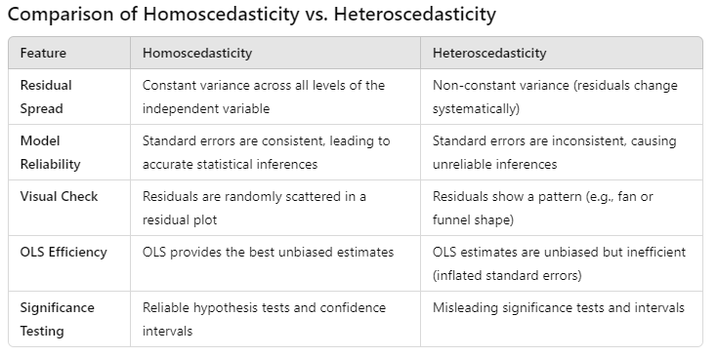**522**

**Which is Better?**

* **Homoscedasticity** is the desired condition in most bivariate regression models. When the residuals are homoscedastic, it ensures that the standard errors of the regression coefficients are consistent and valid, which is critical for hypothesis testing and confidence intervals.
* **Heteroscedasticity** may indicate model misspecification or the need for transformation (e.g., log transformation) to stabilize the variance. Although it doesn’t bias the coefficient estimates, it can significantly reduce the accuracy of the model's predictions and statistical inferences.

**Addressing Heteroscedasticity**

If heteroscedasticity is detected, several remedies can be applied:

1. **Transforming the Dependent Variable**: Applying a log or square root transformation can help stabilize variance.
2. **Weighted Least Squares (WLS)**: Instead of using OLS, WLS assigns weights to observations to correct for unequal variance.
3. **Robust Standard Errors**: Using heteroscedasticity-robust standard errors can correct the impact of heteroscedasticity on inference.

**Conclusion**

In bivariate data science, **homoscedasticity** is preferable as it ensures reliable and accurate model estimates. **Heteroscedasticity**, while not fatal to regression models, complicates interpretation and requires corrective measures to ensure valid statistical conclusions. Recognizing and addressing heteroscedasticity is vital for building robust predictive models.